

www.coughtonparishcouncil.co.uk

AGENDA
Ordinary Meeting of Coughton Parish Council
Date and time: Monday 27th January 2025 – 6.30pm
Place; Coughton C of E Primary School

Dear Councillor
You are hereby summoned to attend an Ordinary meeting of the Parish Council to be held Coughton C of E Primary School on Monday 27th January 2025 at 6:30pm.

S.Whittaker

Sarah Whittaker – Clerk to Coughton Parish Council

MEMBERS OF THE PUBLIC AND PRESS ARE WELCOME TO ATTEND

- WELCOME & APOLOGIES

- DECLARATIONS OF INTEREST

- PUBLIC PARTICIPATION

- APPROVAL OF MINUTES
To approve the minutes of the meeting held on 25th November 2024.

FINANCIAL MATTERS

- RFO Report
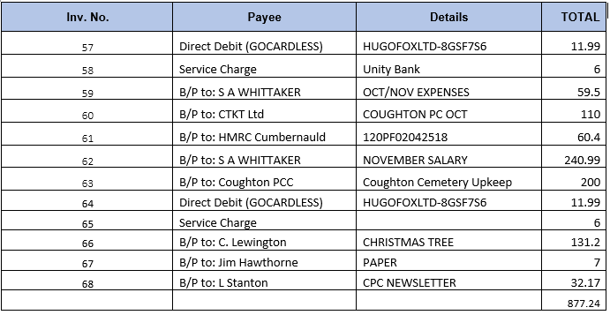
- 2023/2024 Budget DOCUMENT 2
- PRECEPT REQUEST DOCUMENT 3

- PREVIOUS ACTION POINTS
Minute | Name(s) | Action
AP1 March | SA Whittaker | Clerk to check if we can claim on insurance for the replacement bin. Clerk has sent documentation to insurance company for claim. There was some discussion around the citing of the new bin, it was suggested it should be moved closer to the bridge at a higher level, when cited. Ongoing
AP2 May | SA Whittaker | Clerk to enquire if a further inspection by structural engineers or monitoring can take place on the foot bridge over the ford. Clerk requested new inspections with councillor and local resident, awaiting date. Ongoing
2022/23 |  | Replacement of parking signs in Coughton lane- Ongoing
2024 |  | To arrange a meeting with NT re flooding - Ongoing
2024/25 |  | To arrange litter pick - Ongoing

VILLAGE REPORTS
- Flooding, Roads & Pathways – Report from Cllr Lynne Stanton- .
- Community Group –Report from Cllr Christine Lewington – Nothing to report
- Environment Group – Report from Cllr Jim Hawthorne – Nothing to report
- Coughton C of E Primary School – Report from Mr Kolb – No report as he was unable to attend meeting.

- PLANNING

Application(s) reference: 24/02817/LBC CONSENT GRANTED WITH CONDITIONS
Proposed : Re-roofing to the south facing slope of the roof above the saloon (R8A)
At : Coughton Court, Coughton, Alcester, B49 5JA
For : Ms Aimee Tavana The National Trust

Application(s) reference: 24/03245/TREE
Proposed : -G1, x 2- english oak - in the front parkland, tag nos. 0373 & 0374 - crown
reduction as specified in the tree inspection report, in response to the fungal colonisation and
associated dieback and decay of the sapwood around trees' root collars
At : Coughton Court, Coughton, Alcester, B49 5JA
For : Mr Thomas Davison National Trust

To: Coughton Parish Council
Application(s) reference: 24/03244/TREE
Proposed : Removal of various trees adjacent to Cain Brook to facilitate proposed repairs
to the engineered sections of the bank and remove obstructions to the flow, as detailed in the appended reports. NB The northern bank of the brook is the boundary of the conservation area, so it is unclear whether the trees on this side are actually growing within the CA but are included for completeness
At : Coughton Court, Coughton, Alcester, B49 5JA
For : Mr Thomas Davison National Trust

THE STRATFORD-ON-AVON DISTRICT COUNCIL, having considered the application for
permission to develop land at:-
Alne Wood Park Natural Burial Ground, Spernal Lane, Great Alne, Warwickshire
B49 6JG
Submitted by: The Heart of England Forest
Received by the Council on 28 March 2024
HEREBY GIVE YOU NOTICE that PLANNING PERMISSION is GRANTED for the following
development, namely:-
Variation of conditions 1, 2, 3, 8, 9 and 13 of planning permission 23/02812/VARY
dated 17 January 2024 to increase the number of buildings from one to two.

- ORDINARY MEETING DATES 24/25
To agree the meeting dates for the forthcoming year. Proposed dates are:
25th March 2025
19th May 2025
14th July 2025
22nd September 2025
24th November 2025
26th January 2026

- SOUTH WARWICKSHIRE LOCAL PLAN (SWLP) PREFERRED OPTIONS CONSULTATION
To discuss the current consultation and agree parish councils’ response. The consultation can be viewed at http://www.warwickshire.gov.uk/ask

- COUNTY COUNCILLOR J. KERRIDGE
To receive a verbal report.

- DISTRCIT COUNCILLOR S. JUNED
To receive a verbal report

- COUGHTON APPRECIATION AWARD
To discuss nominations and agree recipients.

- CORRESPONDENCE

- COUNCILLOR’S REPORTS and ITEMS FOR FUTURE AGENDAS

- DATE OF NEXT MEETING
24th March 2025 at 6.30pm.

Sarah Whittaker
Parish Clerk
coughtonclerk@gmail.com
www.coughtonparishcouncil.co.uk

