AGENDA

Annual Assembly
of Coughton Parish Council
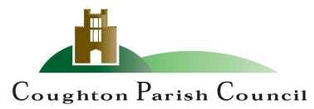

Date and time: Monday 15TH May 2023 at 6:15pm
Place: Coughton C of E Primary School

The Chair and Members of the Parish Council cordially invite you to attend the Annual Parish Assembly to be held at Coughton C of E Primary School, Coughton on Monday 15th May 2023 at 6:15pm.

R Piddington
Cllr Roy Piddington
Chair - Coughton Parish Council

MEMBERS OF THE PUBLIC AND PRESS ARE WELCOME TO ATTEND

- WELCOME and APOLOGIES

- CONFIRMATION OF MINUTES
To approve the minutes of the meeting held on 23rd May 2022 DOCUMENT 1

- THE PARISH COUNCIL YEAR
To receive a report from Cllr Piddington

- COMMUNITY REPORTS
- County Councillor Justin Kerridge
- Amy Spencer – Severn Trent Water
- Councillor Lewington- Environment Group Formation
- Claudine Pearson – WALC
- Ros Anscombe – Heart of England Forest
- MATTERS RAISED BY THE ELECTORATE

- TO CONSIDER CLOSURE OF THE MEETING TO THE PUBLIC and PRESS

Sarah Whittaker
Parish Clerk
coughtonclerk@gmail.com
www.coughtonparishcouncil.co.uk

