

MINUTES
Annual Meeting
of Coughton Parish Council

Date and time: Monday 18th March 2024
Place: Coughton C of E Primary

Attendance: Cllr L. Carter, Cllr L. Stanton, Cllr Lewington and Cllr Hawthorne, Mr Kolb (Headteacher), Simon Pickering, Becca Gee (National Trust) Sarah Whittaker (Parish Clerk), District Councillor Susan Juned, and a 4 Members of the public.

- WELCOME & APOLOGIES
Apologies from Cllr Roy Piddington due to illness and County Cllr Kerridge due to prior commitments.

- DECLARATIONS OF INTEREST
No declarations of interest were received.

- PUBLIC PARTICIPATION

- APPROVAL OF MINUTES
To approve the minutes of the annual meeting held on 15th May 2023 and the ordinary meeting held on 22nd January 2024.
- ELECTION OF CHAIR
In his absence nominations were received by Cllr Lewington for Cllr Piddington to be re-elected as Chairman for the forthcoming 2024/2025 year. All councillors were unanimously in agreement. Proposed by Cllr Stanton seconded by Cllr Hawthorne.

- DECLARATION OF ACCEPTANCE
In his absence it was agreed by the council that the Chairman to sign the declaration of acceptance at the next meeting of the parish council.

- ELECTION OF VICE CHAIR
It was proposed by Cllr Stanton and unanimously agreed to elect Cllr Christine Lewington as Vice-Chair for the 2024/2025 year. Proposed Cllr Stanton seconded by Cllr Hawthorne.

- DECLARATION OF ACCEPTANCE
Cllr Christine Lewington duly signed the Declaration of Acceptance.

- AREAS OF RESPONSIBILITY
To agree Parish Councillors areas of responsibility
Current responsibilities are:
- Risk Assessments – Cllr Lewington
- Planning –ALL COUNCILLORS
- Defibrillator – Cllr Piddington/Cllr Stanton
- Employment/HR – Cllr Piddington/Cllr Lewington
- Communications – Cllr Stanton
- Flooding – Cllr Stanton
- Community Group – Cllr Lewington
- Finance – Cllr Carter
- Environment Group (incorporating Trees and Ford group)– Cllr Hawthorne

Proposed by Cllr Stanton, seconded by Cllr Hawthorne

- GOVERNANCE EMAILED
To agree the following:
- Financial Regulations
- Standing Orders
- Code of Conduct

Proposed by Cllr Stanton, seconded by Cllr Hawthorne

FINANCIAL MATTERS

EMAILED
- RFO Report DOCUMENT 1
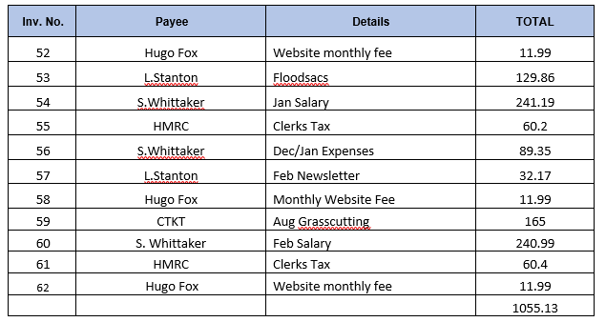

Proposed by Cllr Lewington, seconded by Cllr Stanton

- To approve the purchase of gov.uk domain names for parish council website and Clerk and Councillor email addresses- agreed to purchase website domain name and hold fire on council gov.uk email addresses.
- To agree the purchase of speeding and litter signs for the village.
- To approve a donation to Alcester First Responders for the recent defibrillator training. All in agreement to donate £70 Proposed by Cllr Stanton and seconded by Cllr Lewington.
- Agree repurchase of Parish bin near Ford at a cost of - £250 +VAT Installation is £150 +VAT
It was agreed that the Clerk would investigate if the bin could be claimed on the Parish Council insurance. It was also queried if it be moved to slightly higher ground by the oak tree to prevent it being washed away again. AP1 MARCH - Clerk to check if we can claim on insurance for the replacement bin.
It was proposed by Cllr Stanton and seconded by Cllr Hawthorne to approve all of the above payments and to purchase a new bin if the council cannot claim on insurance.

- CHANGE OF MEETING DATE AND EXTAORDINARY MEETING DATE
It was agreed that the council will hold an extraordinary meeting to approve the AGAR on Monday 20th May 2024 and the July meeting date will be held on Monday 15th July 2024.

- PREVIOUS ACTION POINTS
AP5/July Agreed to arrange a multi-agency meeting regarding the speeding particularly by the school on the A435. Letter received from WCC via Nadim Zawahi which was read at the meeting. There was disappointment expressed at the lack of action from the County Council and alternatives were discussed such as banning the parking of cars in the immediate vicinity of the school but there were no safe or financially viable alternatives. ONGOING

- D DAY 80TH ANNIVERSARY VILLAGE REMEMBERANCE
The Parish council proposed holding a commemorative picnic in the mews with the option of 1940s dress on the 6th June 2024. Cllr Lewington had liaised with the school and the parish council would be judging a competition at the school as part of the celebrations.

- FLOOD RELIEF PROPOSALS
In Cllr Kerridge’s absence Cllr Stanton highlighted the work that had taken place in the village which included jetting and cameras down all drains on Coughton Field Lane which had uncovered a collapsed manhole. As a result, two new manholes were installed to allow for easier jetting resulting in much improved flow. Cllr Stanton had further questions for Cllr Kerridge’s proposals and would discuss this at another meeting. Cllr Lewington highlighted that a majority of the flooding is impacting the cottages as most of the water runs off the field behind the cottages. There used to be a balance pond which has now been filled in. Can we have a meeting with the National Trust to discuss how the properties can be protected and prevent run off from the field. It was agreed that Cllr Hawthorne will meet with the Estates Manager to discuss.

- VILLAGE REPORTS
Cllr Stanton reported that there are still ongoing potholes that currently have temporary repairs. New drains will be installed at the Fordrough and Samborne Lane which will be done in the next financial year when new budgets are available.

- COUNCILLOR’S REPORTS and ITEMS FOR FUTURE AGENDAS
Cllr Lewington presented the action plan for the forthcoming year for the council.

- DATE OF NEXT MEETING
- 20th May 2024 at 6:30pm

Sarah Whittaker
Parish Clerk
coughtonclerk@gmail.com
www.coughtonparishcouncil.co.uk

