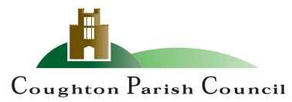

www.coughtonparishcouncil.co.uk

AGENDA
Extraordinary Meeting of Coughton Parish Council
Date and time: Monday 10th February 2025 – 6.30pm
Place; Coughton C of E Primary School

Dear Councillor
You are hereby summoned to attend an Ordinary meeting of the Parish Council to be held Coughton C of E Primary School on Monday 10th February 2025 at 6:30pm.

S.Whittaker

Sarah Whittaker – Clerk to Coughton Parish Council

MEMBERS OF THE PUBLIC AND PRESS ARE WELCOME TO ATTEND

- WELCOME & APOLOGIES

- DECLARATIONS OF INTEREST

- PUBLIC PARTICIPATION

- APPROVAL OF MINUTES
To approve the minutes of the meeting held on the 27th January 2025.

- ACTION TRACKER
Clerk to demonstrate use of Action Tracker and agree ongoing use of the tracker as a collective.

- EXPENIDTURE OF CIL FUNDS
To agree the expenditure of CIL funds. Current funds held are:

2023 – 2357.40
2024 – 2717.27
TOTAL 5074.67

- CORRESPONDENCE

- COUNCILLOR’S REPORTS and ITEMS FOR FUTURE AGENDAS

- DATE OF NEXT MEETING
24th March 2025 at 6.30pm.

Sarah Whittaker
Parish Clerk
coughtonclerk@gmail.com
www.coughtonparishcouncil.co.uk

