AGENDA

Annual Assembly
of Coughton Parish Council
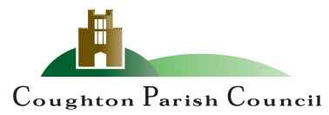

Date and time: Monday 19th May 2025at 7:00pm
Place: Coughton C of E Primary School

The Chair and Members of the Parish Council cordially invite you to attend the Annual Parish Assembly to be held at Coughton C of E Primary School, Coughton on Monday 19th May at 7:000pm.

R Piddington
Cllr Roy Piddington
Chair - Coughton Parish Council

MEMBERS OF THE PUBLIC AND PRESS ARE WELCOME TO ATTEND

WELCOME and APOLOGIES

- CONFIRMATION OF MINUTES
To approve the minutes of the meeting held on 18th March 2024 DOCUMENT 1

- THE PARISH COUNCIL YEAR
To receive a report from Cllr Piddington

- COUGHTON APPRECIATION AWARD

- COMMUNITY REPORTS
- County Councillor Luke Cooper
- District Councillor Susan Juned
- Andy Parsons – Heart of England Forest
- Mr Magnus Birch- Throckmorton – Coughton Court
- MATTERS RAISED BY THE ELECTORATE

Sarah Whittaker
Parish Clerk
coughtonclerk@gmail.com
www.coughtonparishcouncil.co.uk

